**8 SCIENCE 2016**

### CHEMISTRY TEST TWO

Name: ____________________ Teacher (please circle): LAFFERTY/CERNY/NORGROVE/MILNER

Mark: /53 Percentage: %

**ANSWER KEY**

**SECTION A: MULTIPLE CHOICE (30 marks)**

**Select the most correct answer for each question below.**

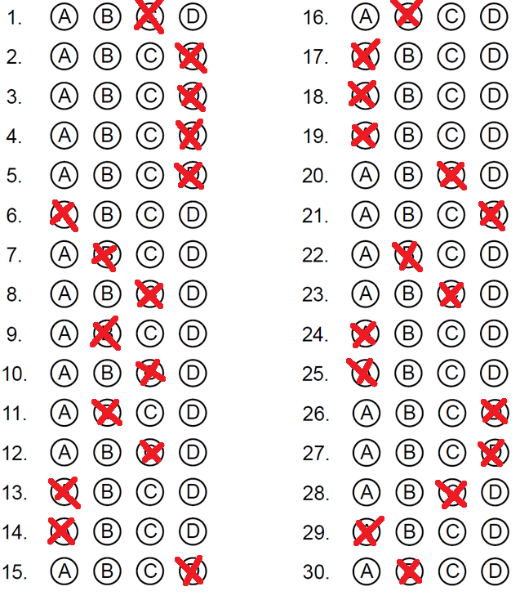

**1.** An element that consists of just single atoms is known as:

(a) Ditomic.

(b) Unitomic.

**(c) Monatomic.**

(d) Molecule.

**2.** A STM is an abbreviation for a special microscope called a:

(a) Spectrum Tunnelling Microscope.

(b) Scanning Telescopic Microscope.

(c) Small Telescopic Microscope.

**(d) Scanning Tunnelling Microscope.**

**3.** Choose the statement that is true.

(a) Compounds are also elements.

(b) Molecules are also mixtures.

(c) Compounds are also monatomic elements.

**(d) Compounds are also molecules.**

**4.** Air is an example of:

(a) An element.

(b) A molecule.

(c) A compound.

**(d) A mixture.**

**5.** Look at the diagram on the right. The diagram shows a:

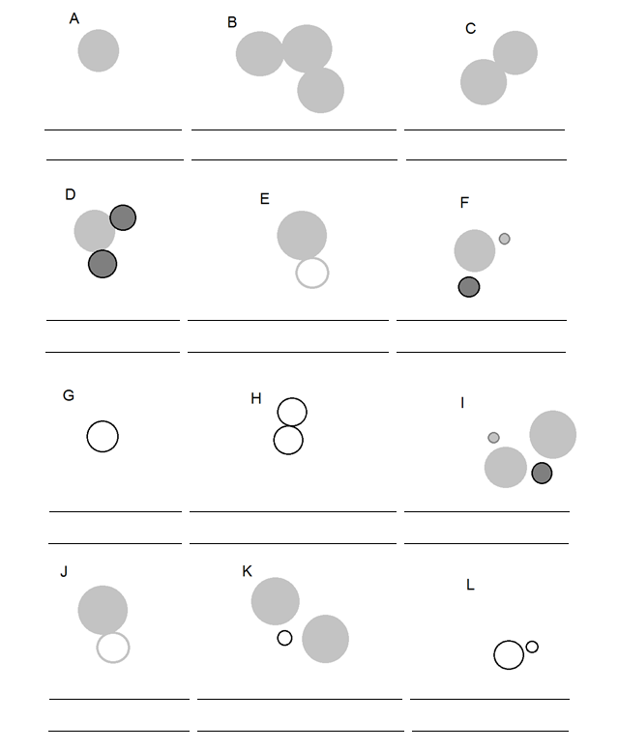

(a) Element.

(b) Mixture.

(c) Compound.

**(d) Molecular compound.**

**6.** Choose the correct definition for ‘element’.

**(a) A substance made up of one type of atom.**

(b) A substance made up of more than one type of atom.

(c) The fundamental building blocks of all materials.

(d) The smallest particles that make up everything.

**7.** Look at the diagram on the right. The diagram shows a:

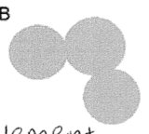

(a) Molecule.

**(b) Element and molecule.**

(c) Molecule and compound.

(d) Compound and element.

**8.** Choose the correct definition for ‘miscible’.

(a) Liquids that do not mix together.

(b) A gas and liquid that do not mix together.

**(c) Liquids that can be mixed together.**

(d) A solid and liquid that can be mixed together.

**9.** If a substance is a poor conductor of electricity, this means that:

(a) The substance does not allow heat to pass through it.

**(b) The substance does not allow electricity to pass through it.**

(c) The substance allows heat to pass through it.

(d) The substance allows electricity to pass through it.

**10.** Look at the diagram on the right. The diagram shows a:

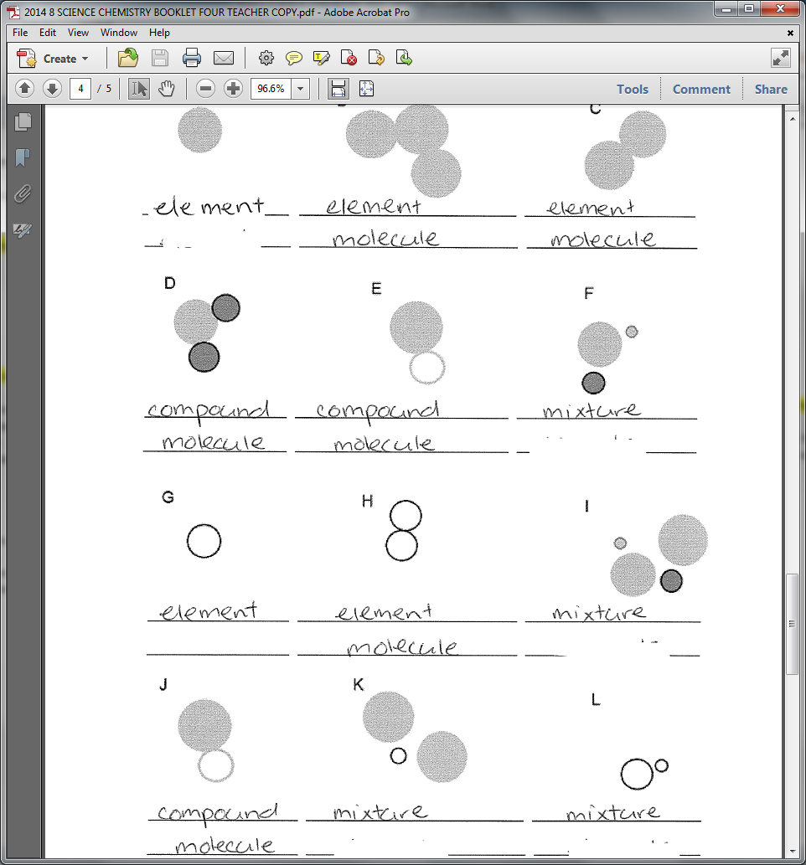 (a) Compound and mixture.

(b) Molecular compound.

**(c) Mixture.**

(d) Element and mixture.

**11.** Choose the correct definition for ‘brittle’.

(a) Can be bent or stretched.

**(b) Breaks or crumbles when bent.**

(c) Substances that are not shiny.

(d) Can be stretched into wires.

**12.** How many known elements are there that occur naturally?

(a) 118.

(b) 84.

**(c) 92.**

(d) 150.

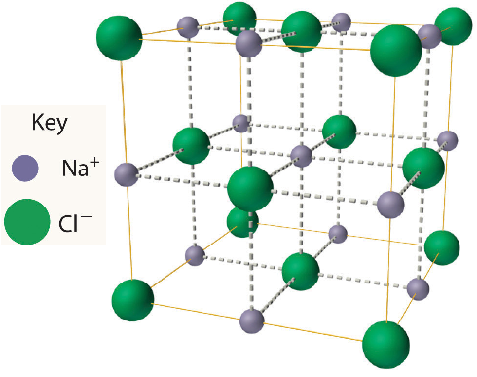**13.** The compound, sodium chloride (NaCl), has a shape represented in the diagram below. The shape is called:

**(a) a crystal lattice.**

(b) a sodium compound

(c) a salt lattice.

(d) a crystal cube.

**14.** Choose the correct definition for ‘properties’.

**(a) The characteristics of a substance.**

(b) The physical structure of a substance.

(c) The fundamental building blocks of all materials.

(d) The appearance of a substance.

**15.** How many known elements are there?

(a) 142.

(b) 92.

(c) 121.

**(d) 117.**

**16.** Choose the correct term for the definition: ‘can be bent or hammered into sheets’.

(a) Mouldable.

**(b) Malleable.**

(c) Bendable.

(d) Ductile.

**17.** Which of these is the smallest particle?

**(a) An atom.**

(b) A molecule.

(c) A compound.

(d) A speck of dust.

**18.** Which statements about elements is correct?

**(a) Most elements are metals.**

(b) Most elements are non-metals.

(c) There are about the same number of metals and non-metals.

(d) Most elements are metalloids.

**19.** Where are metals found in the periodic table?

**(a) On the left.**

(b) On the right.

(c) Scattered all over.

(d) In the middle.

**20.** Which of the following is not a general property of metals?

(a) Shiny.

(b) Good conductor of heat.

**(c) Poor conductor of electricity.**

(d) Malleable.

**21.** Which of the following is not a general property of non-metals?

(a) Brittle.

(b) Poor conductor of heat.

(c) Poor conductor of electricity.

**(d) Shiny.**

**22.** The symbol for potassium is:

(a) Pt.

**(b) K.**

(c) Po.

(d) P.

**23.** Solder is an alloy (metal mixture) of tin and lead. It is used to connect electrical wiring together

because it conducts electricity well and has a low melting point, but sets hard once it’s cooled.

The melting point of the solder alloy depends on the proportions of tin and lead in the solder.

Mark wants to use solder to connect some copper wires to a very sensitive electrical circuit. It is

important that the electrical circuit does not get too hot so Mark must find the solder alloy with

the lowest melting point. Use the graph below to determine what type of solder Mark should use

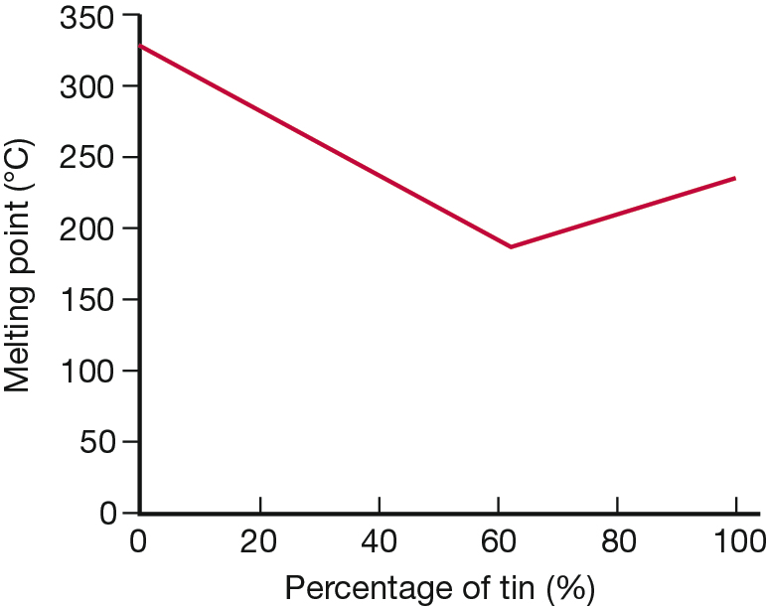 to protect his electrical circuit.

(a) 0% tin and 100% lead.

(b) 50% tin and 50% lead.

**(c) 60% tin and 40% lead.**

(d) 100% tin and 0% lead.

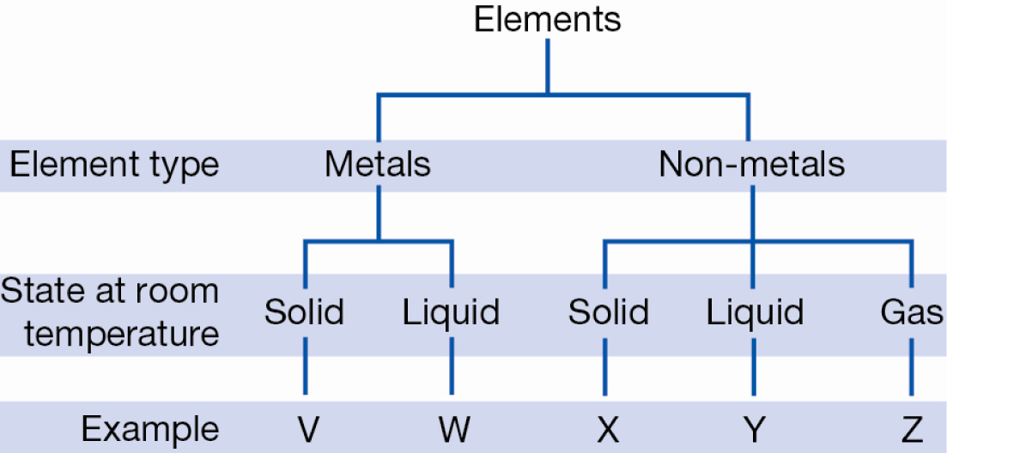**24.** The chart on the right divides elements into 5 groups where the letters V, W, X, Y and Z represent an example of each. Given that bromine is the only non-metal liquid at room temperature, it can be inferred that bromine could be:

**(a) Y only.**

(b) W or Y.

(c) W only.

(d) X, Y or Z.

**25.** Chemists use symbols to identify each element. Recall which feature is true of these symbols.

**(a) They mostly contain one or two letters.**

(b) They always use the first letter of the element name.

(c) They are arranged in the periodic table alphabetically.

(d) They must only use capital letters.

**26.** The molecular formula for a compound tells you what type of atoms are in the molecules and how many of each. A common compound found in coffee, bread and ripe fruit is acetaldehyde, which has the molecular formula C2H4O. Which of the following diagrams would best represent a molecule of acetaldehyde?

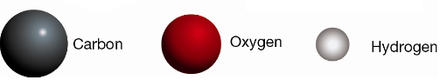

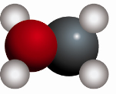

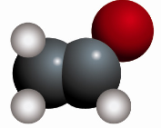 (a) (b)

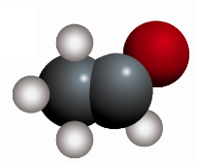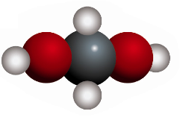

(c) **(d)**

**27.** Small solid particles mixed with a gas is called:

(a) Mist.

(b) Smoke.

(c) Dust.

**(d) Both (b) and (c).**

**28.** The only metal element that is liquid in room temperature is:

(a) Tin.

(b) Bromine.

**(c) Mercury.**

(d) Sodium.

**29.** Which of the following best represents a molecule of water (H2O).

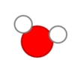 **(a)**  (b)

 (c) (d)

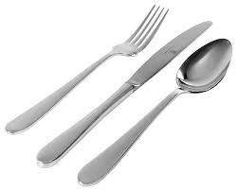**30.** Stainless steel is a mixture of a metal with other metals. Cutlery is usually made from stainless steel. Stainless steel is an example of:

(a) Aluminium.

**(b) An alloy.**

(c) An element.

(d) Miscible mixture.

**SECTION B: SHORT ANSWER (23 marks)**

**1.** Complete the table which shows the properties of metals and non-metals. (8 marks)

|  |  |  |
| --- | --- | --- |
| Property | Metals | Non-metals |
| Appearance | **Shiny** | **Dull/not shiny** |
| Malleable or brittle | **Malleable** | **Brittle** |
| Conduction of heat (good or poor) | **Good** | **Poor** |
| Conduction of electricity  (good or poor) | **Good** | **Poor** |

**3.** Explain the main difference between an element and a compound. (2 marks)

**Elements are made up of only one type of atom (1) whereas a compound is made up of more than one type of atom (1).**

**14.** Fill in the table below. (13 marks)

|  |  |
| --- | --- |
| **Element** | **Symbol** |
| Helium | **He** |
| **Beryllium** | Be |
| **Phosphorus** | P |
| Calcium | **Ca** |
| **Lithium** | Li |
| **Boron** | B |
| Silicon | **Si** |
| **Sulfur/sulphur** | S |
| **Chlorine** | Cl |
| **Nitrogen** | N |
| **Fluorine** | F |
| Argon | **Ar** |
| **Magnesium** | Mg |